The ICD®
Learning Management System (LMS)

May 5, 2020
Handout updated Nov 19, 2021

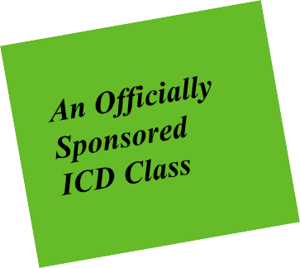

www.challengingdisorganization.org
©2020 Institute for Challenging Disorganization All rights reserved.

The ICD®
Learning Management System (LMS)

- This class is a non-credit instructional class
- Subscribers will learn how to access classes in the LMS, confirm classes, apply classes to certificates, see Continuing Education Credits in their ICD subscriber profiles.

www.challengingdisorganization.org
The ICD® Learning Management System ©2020 Institute for Challenging Disorganization
.All rights reserved.

Lynne Poulton, Director of Marketing

Laurene Livesey Park, Certification Program Director

Purpose of this class:
- Walk-through of the process of accessing, taking and confirming a class in the ICD Learning Management System.
- Review of where to find ICD class credits.
- Look at subscriber profiles in the ICD website.
- Answer questions!

Learning Management System (LMS)
- Platform to organize, host and track online education
Personify
- ICD’s web hosting company
- Our education is available on the LMS, our profiles are on our website on Personify. They are linked, you no longer need a separate log-in to access ICD classes, and classes taken in the LMS will show up in your subscriber profile.
Continuing Education Credits (CEUs)*
- These are ICD® credits – for ICD certificates and ICD recertification. They may be valid for other uses, we do not monitor that.
*Note that free classes are not eligible for CEU credit.

Navigate to ICD website
Click on Member Login
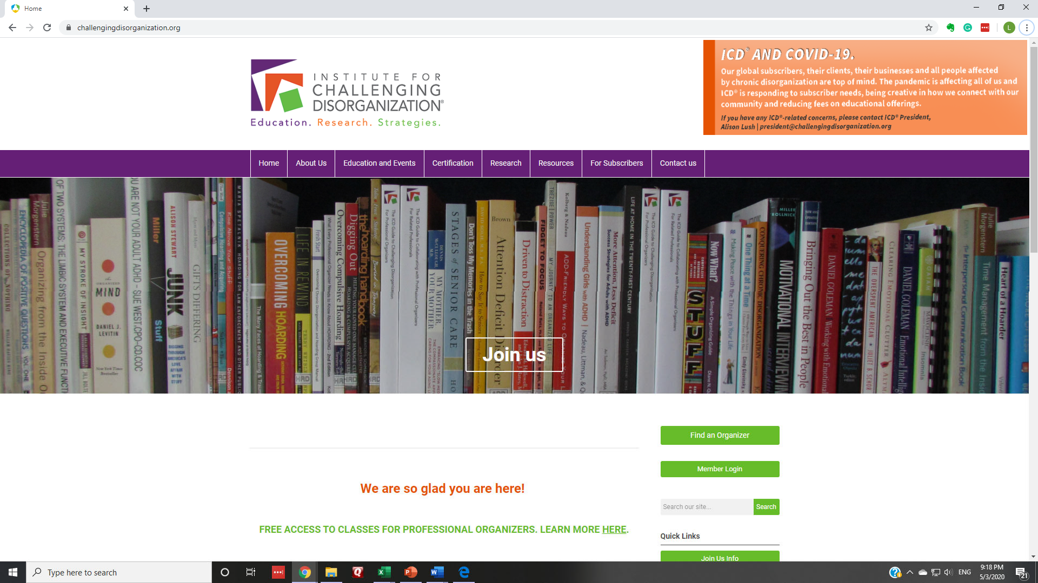

Click on Log In
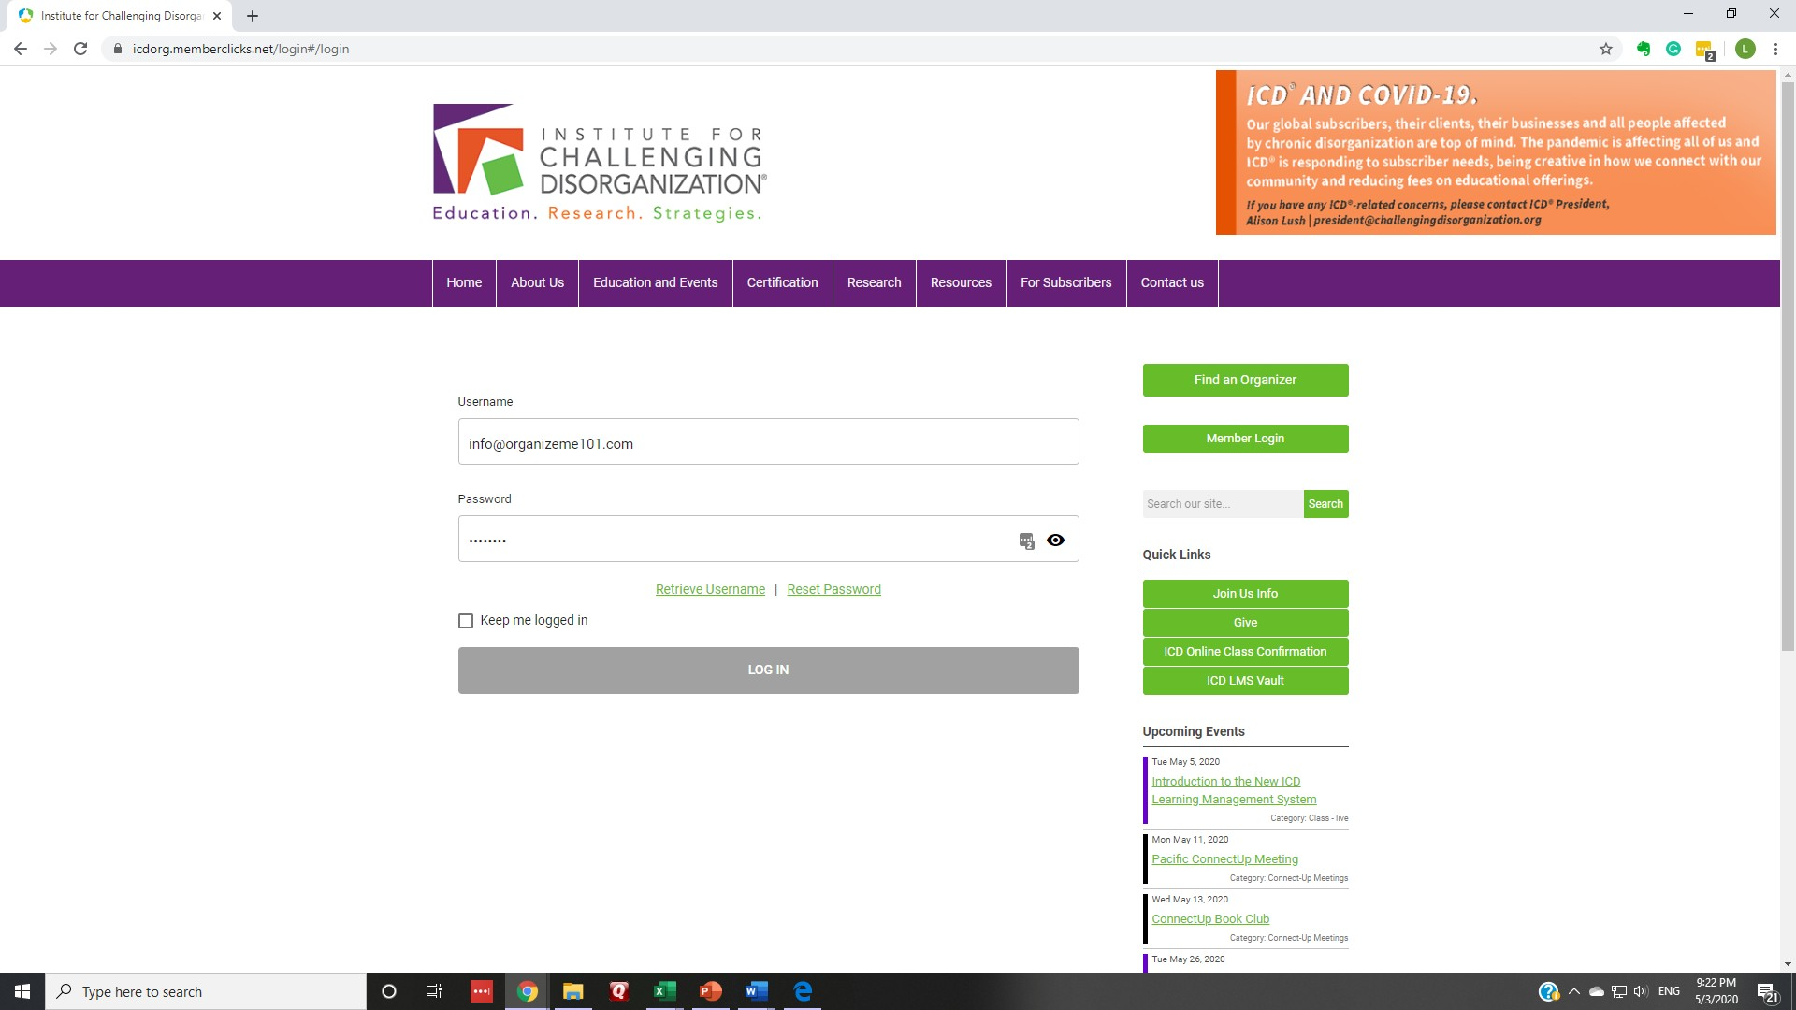

Right Click on ICD LMS Vault and open
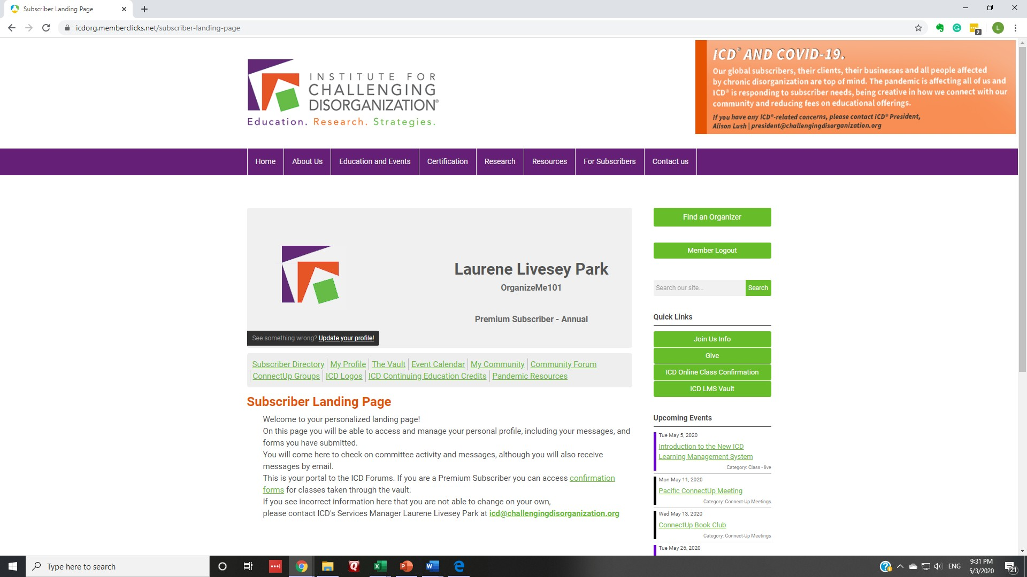in new tab

You Made It!
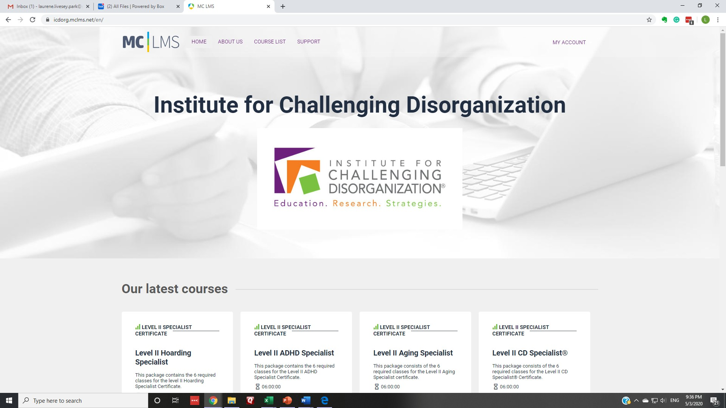Click on Course List

Click on Filter By
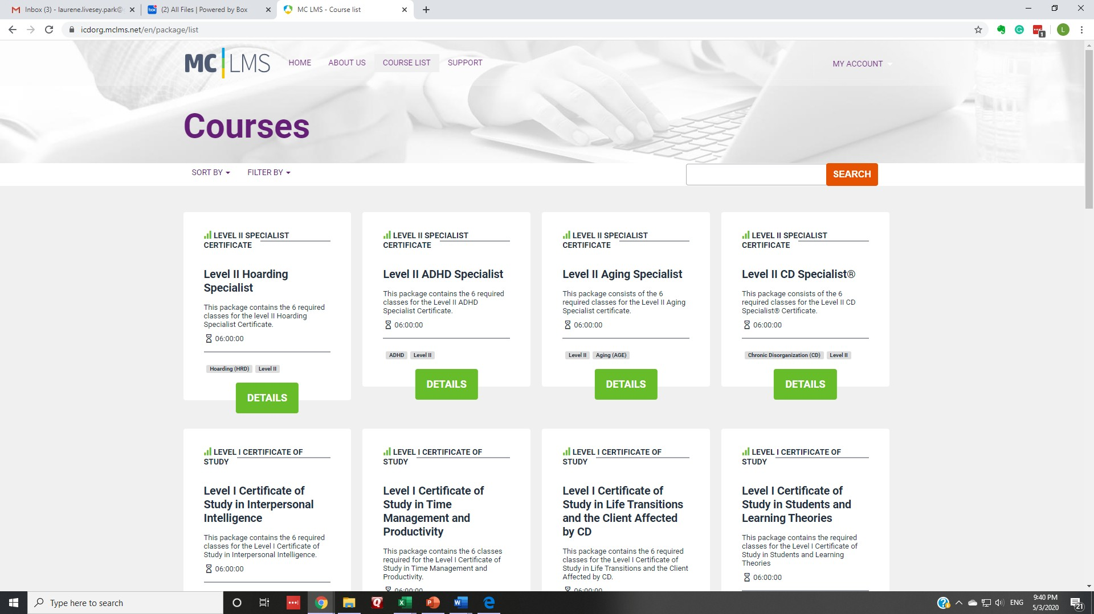

What class do you want to access?
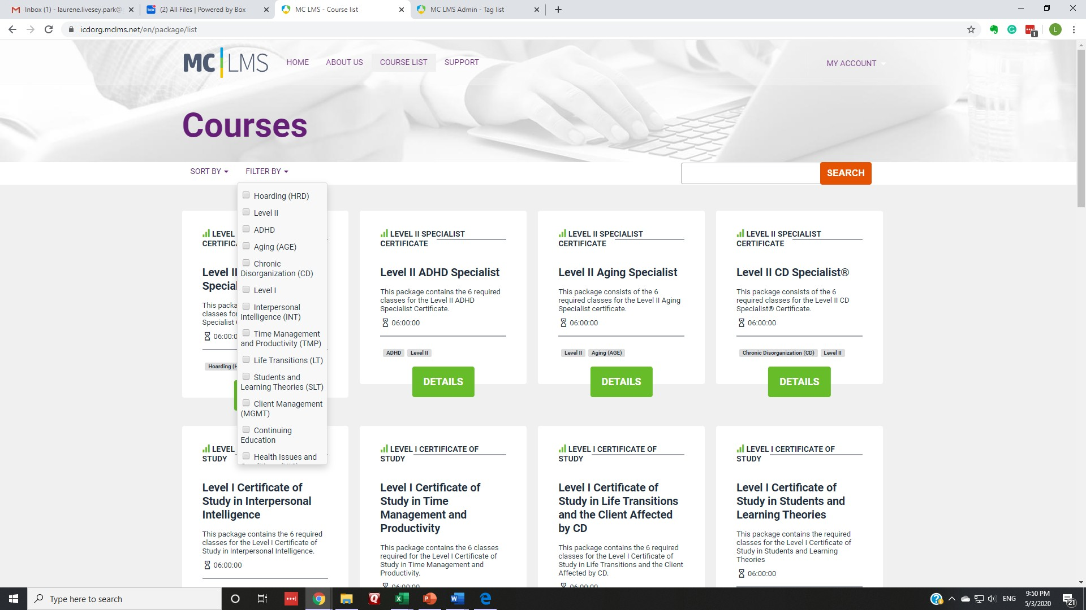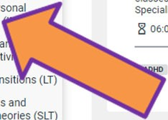

Let’s take a Level I INT class
Note: If you are just starting out, choose the Foundation Certificate of Study!
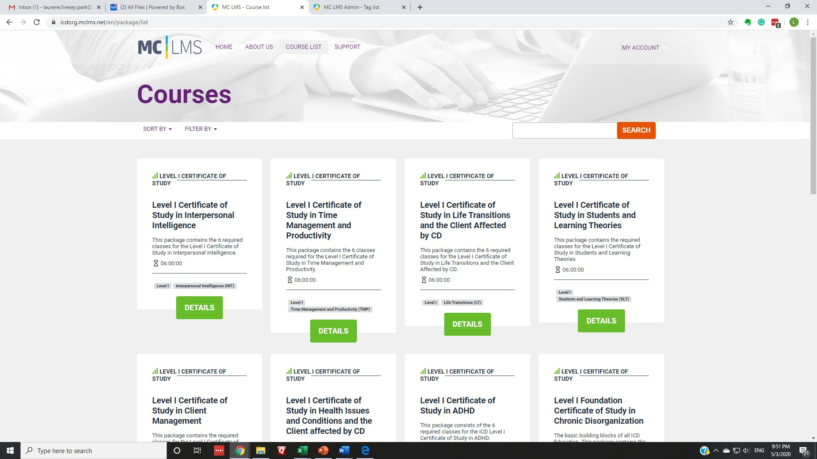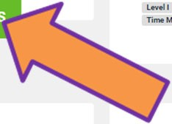

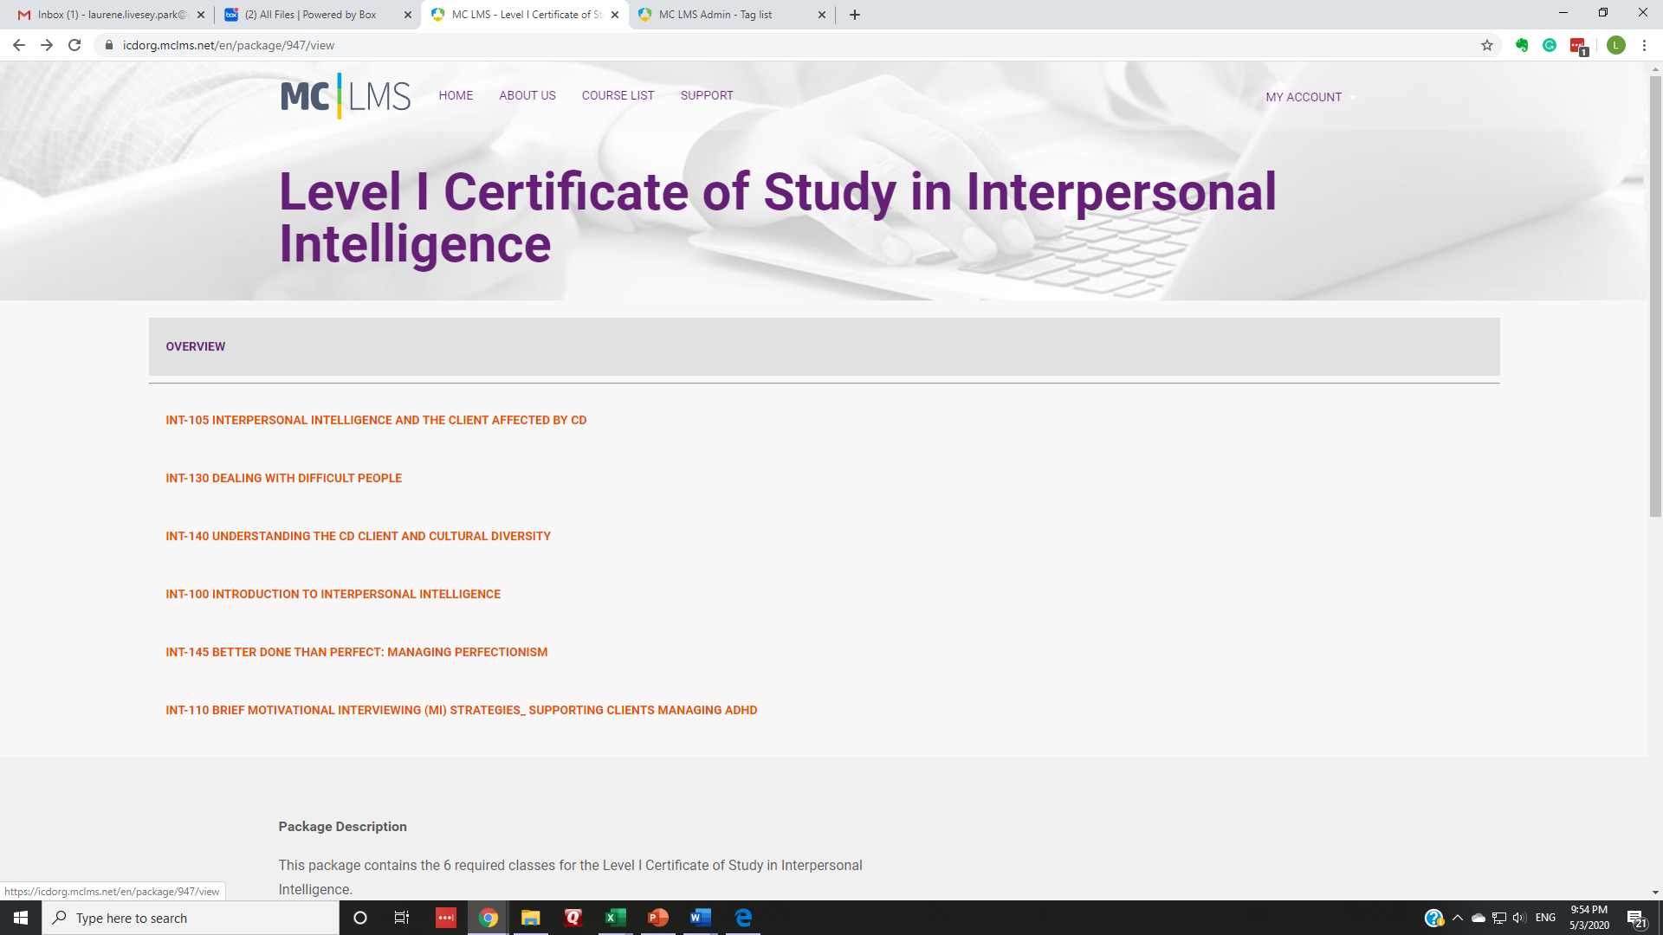Choose class, click

Scroll down to access lesson and
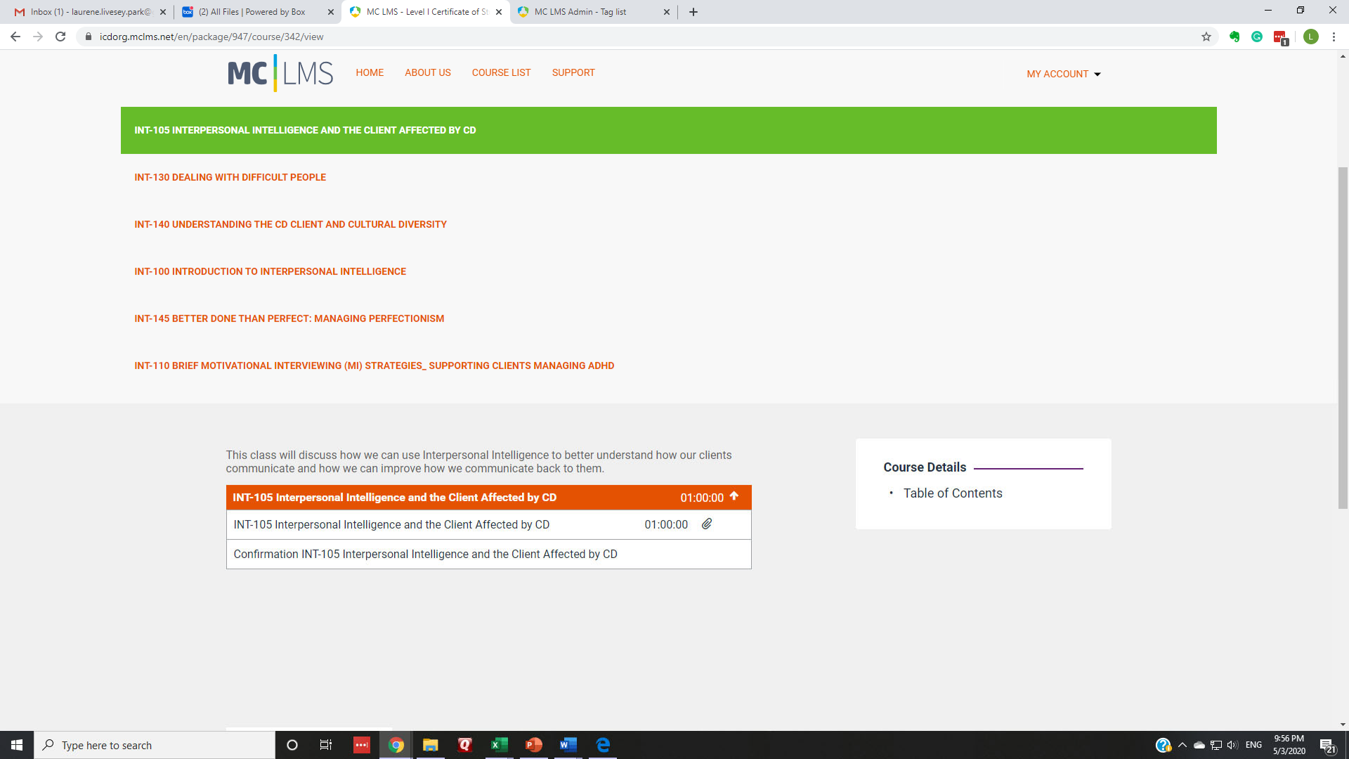confirmation

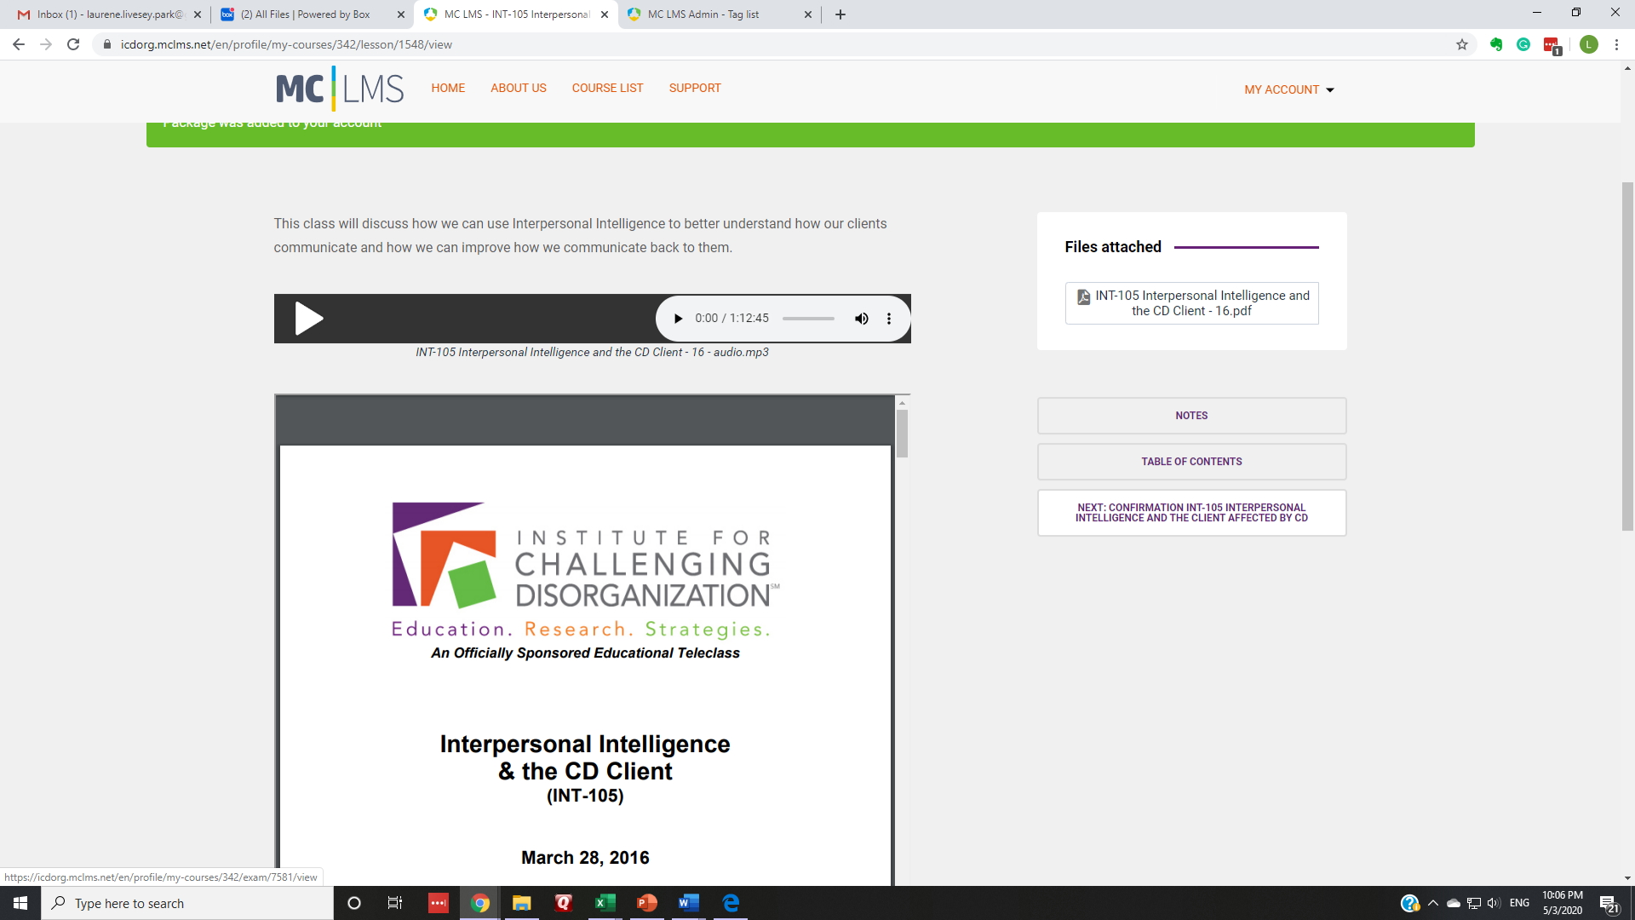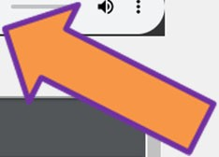Class Content

Class Content
Class Confirmation
Note: Class Confirmations are not available for free classes

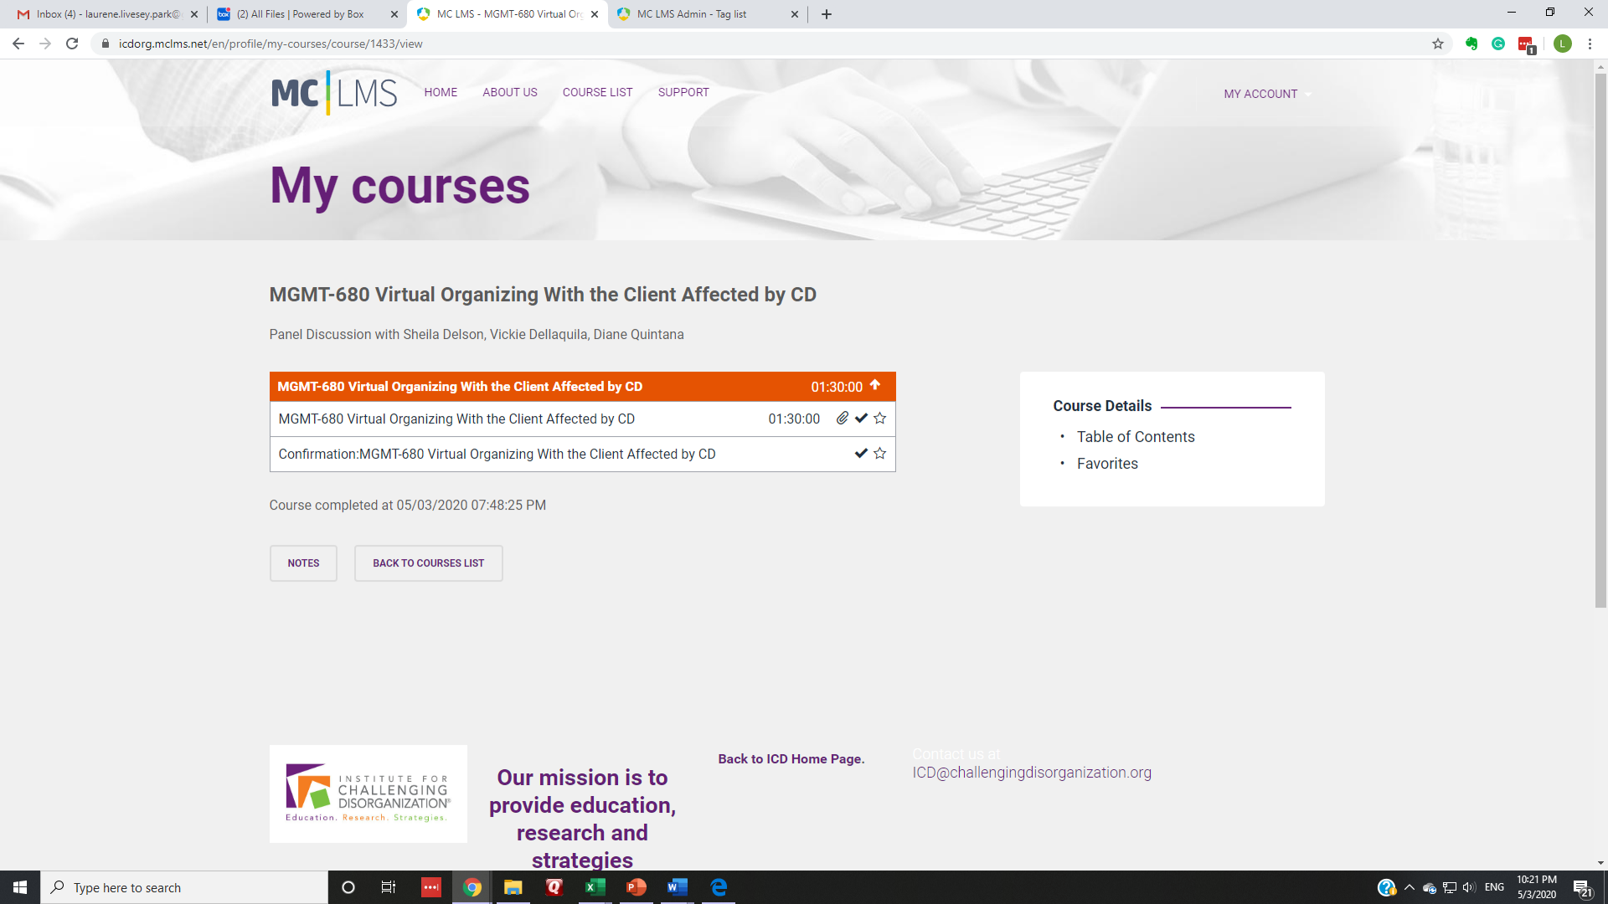 Very Important Confirmation Check

Back to ICD Home Page, or click the
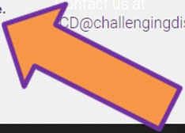tab open in your browser

Back to your subscriber profile,
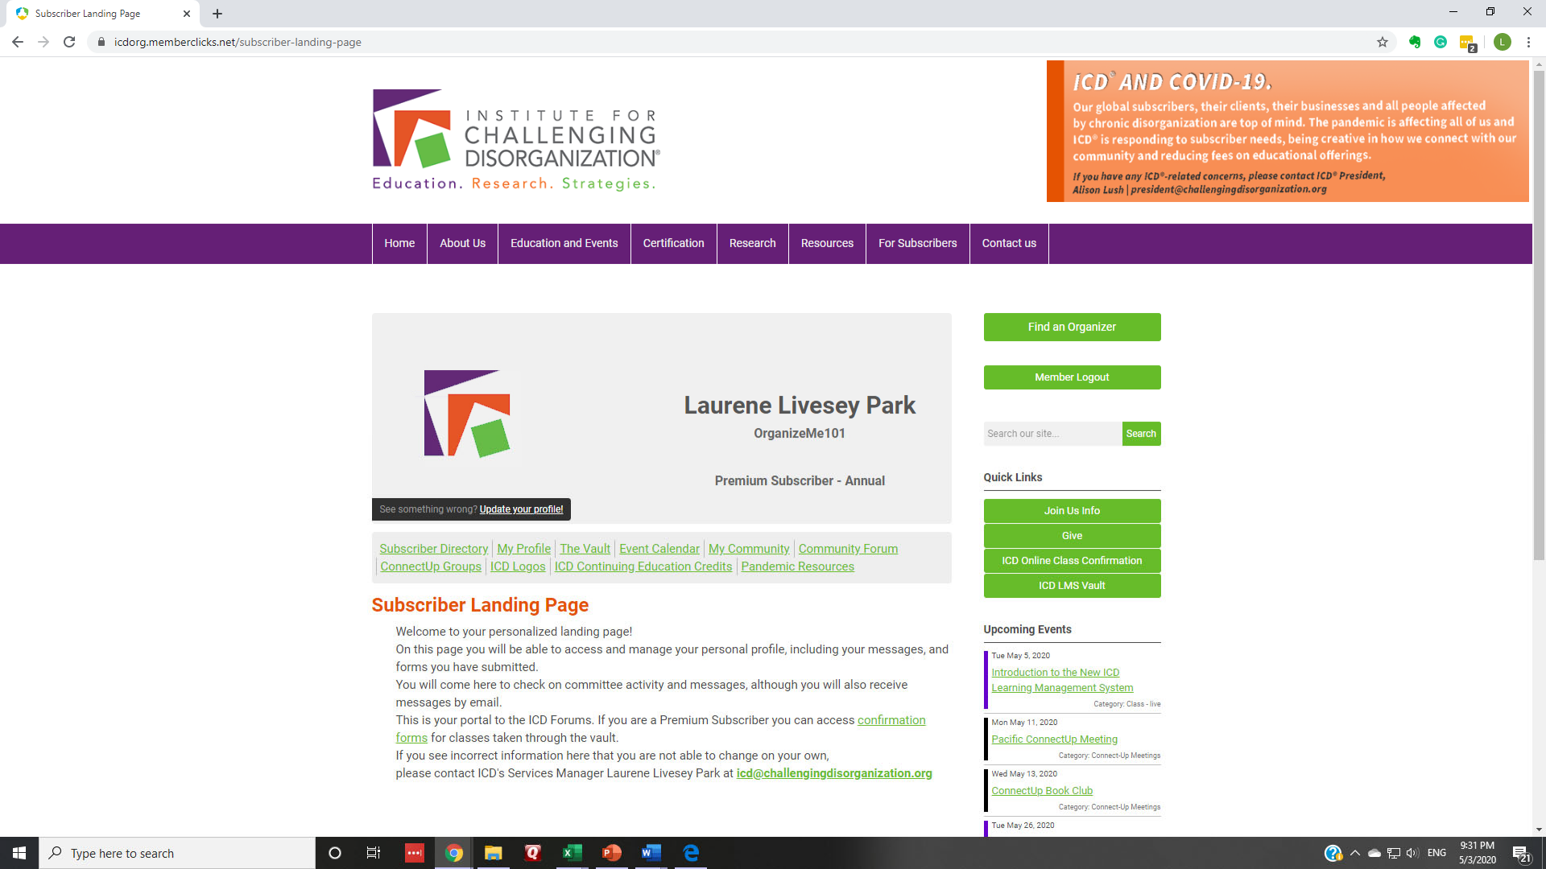Click on ICD Continuing Education Credits

Sortable ICD® CEUs

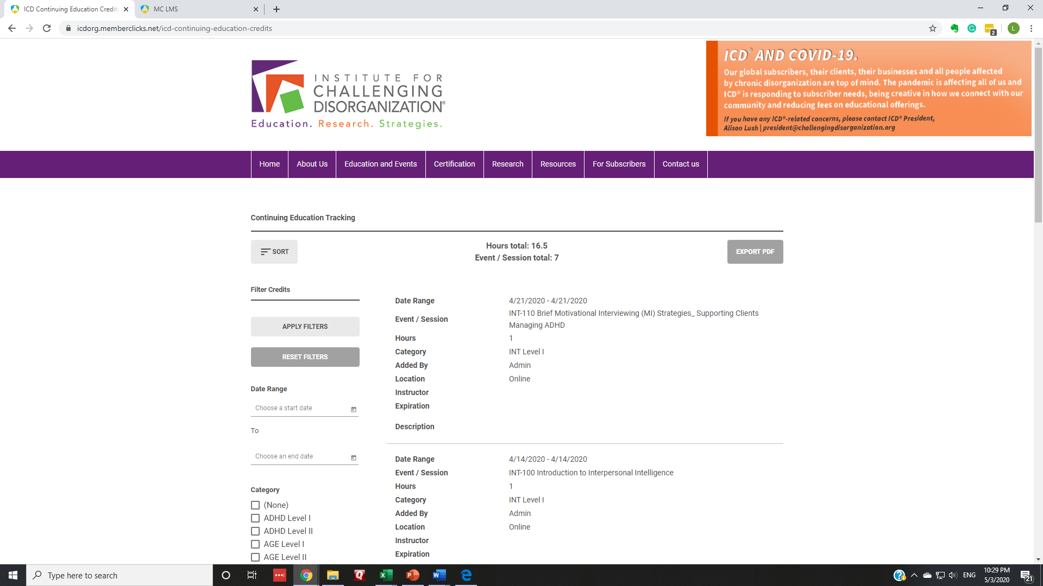

PDF of credits

What else is in your profile?

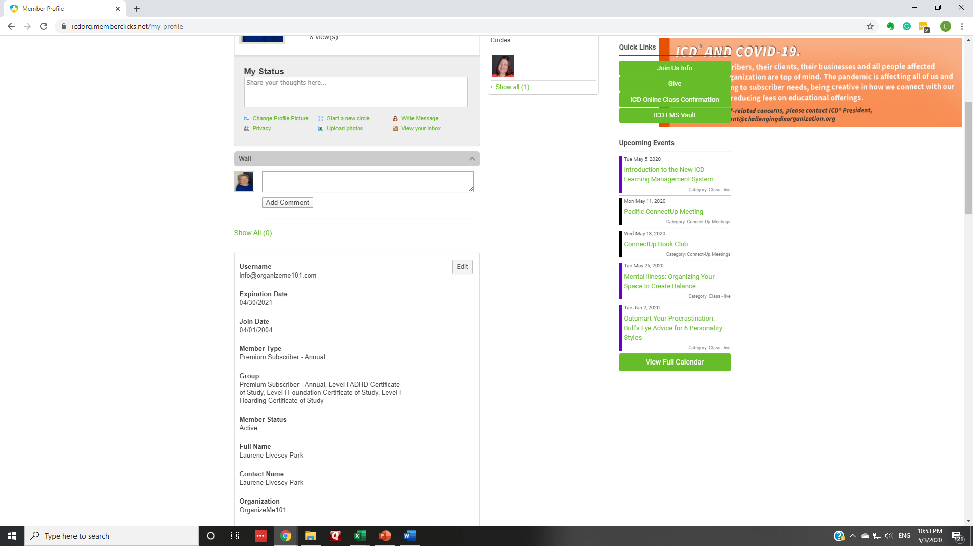

Editable!

Applying for ICD® certificates
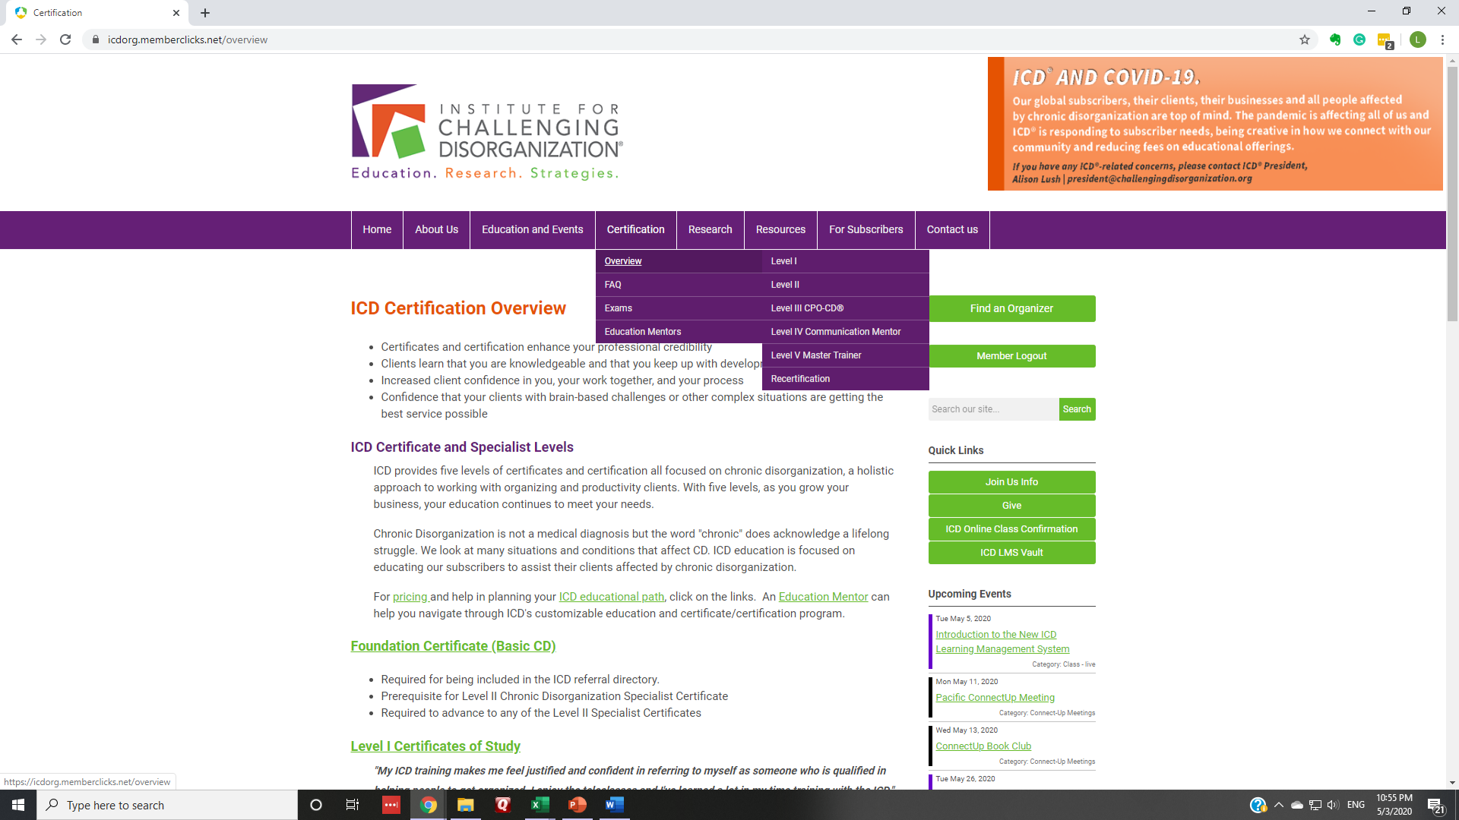Choose the Level you wish to access

Choose the Certificate you wish to
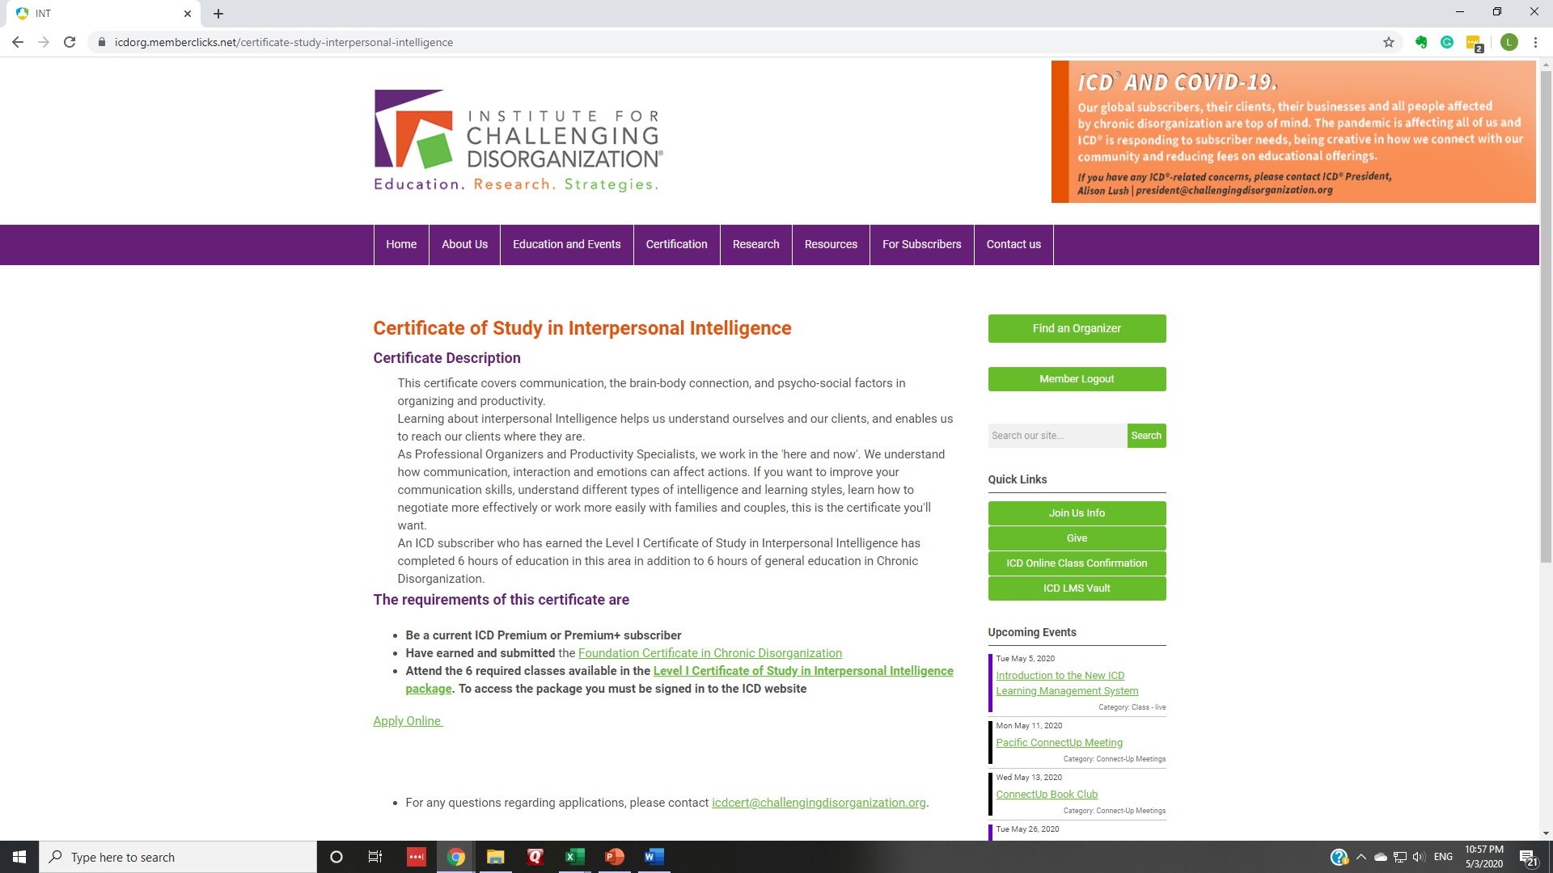access, click Apply Online

Fill in the form and pay!

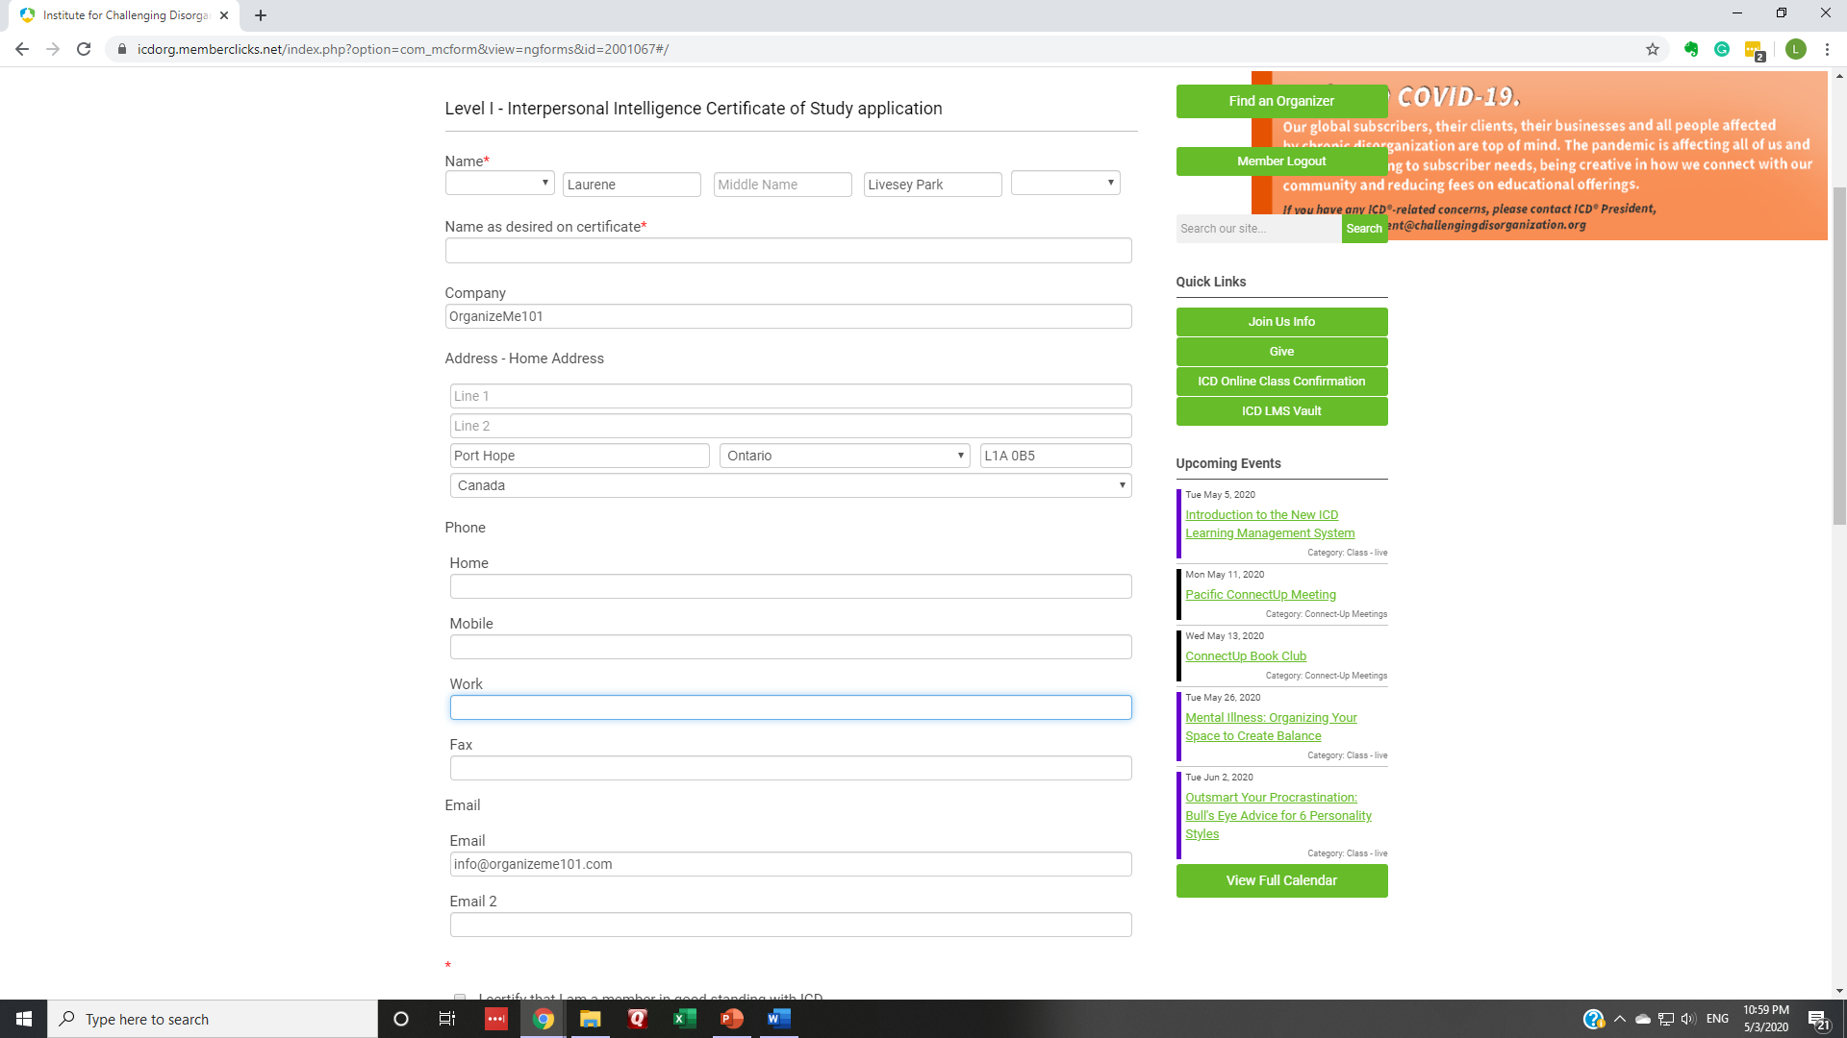

Level II Specialist Certificates

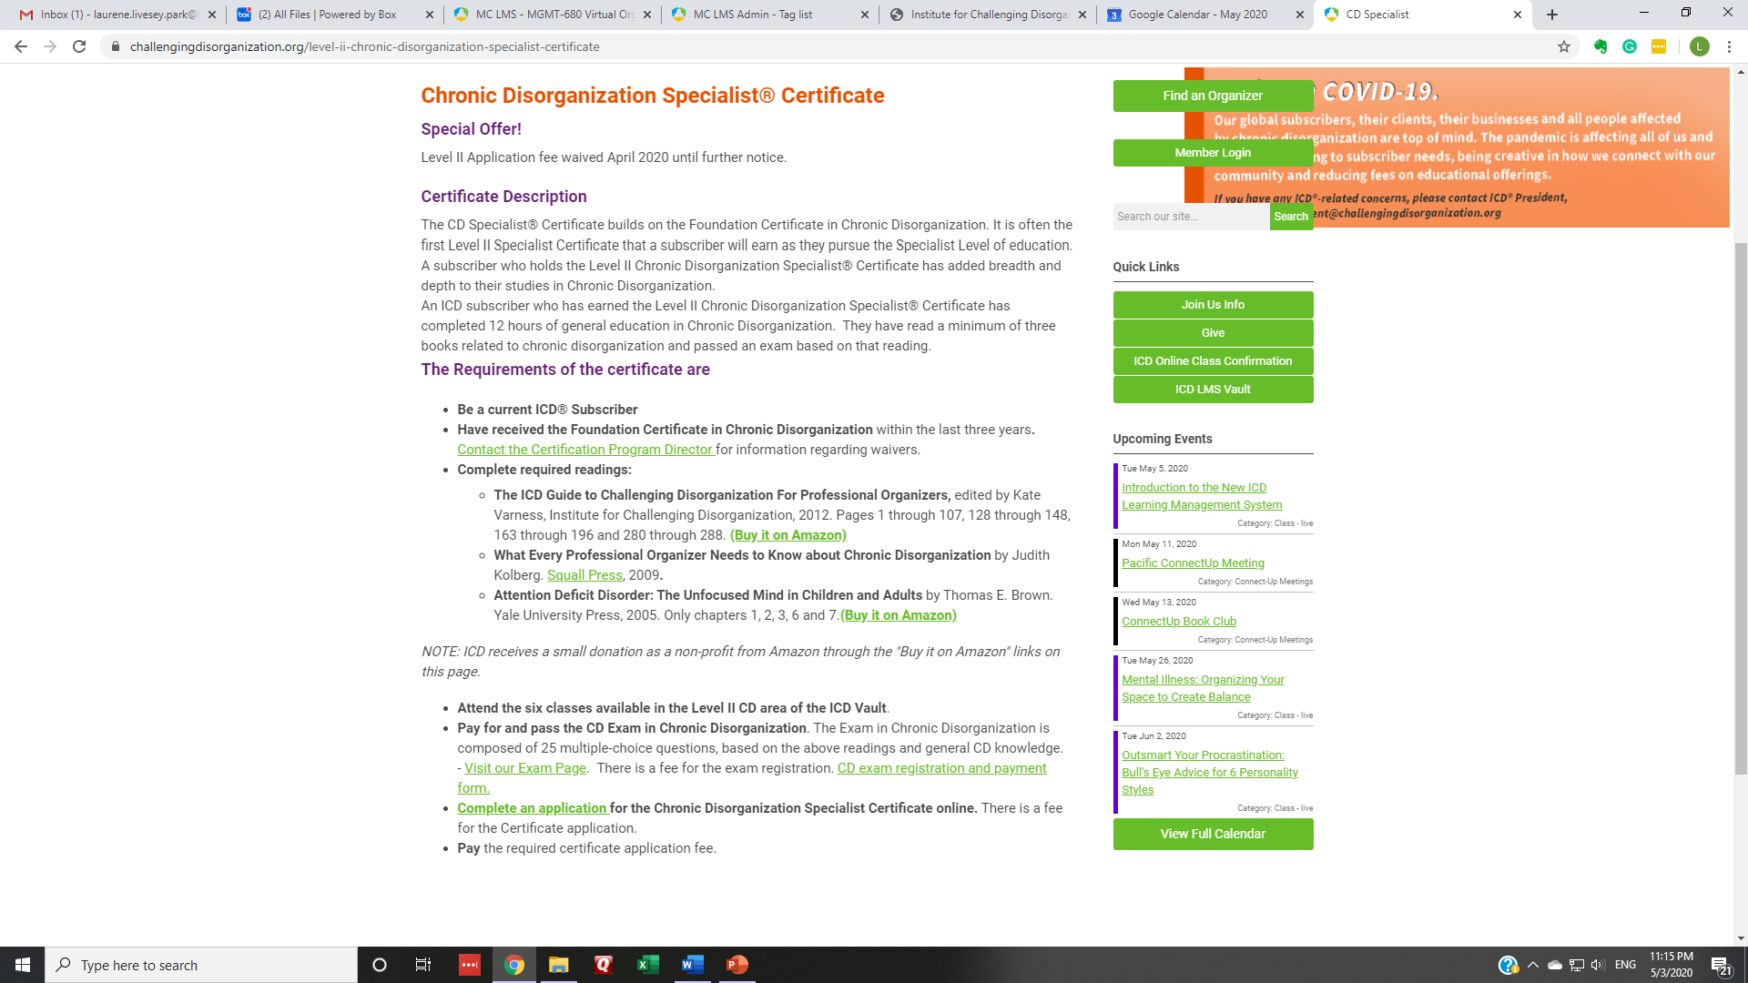

Level II Specialist Exams

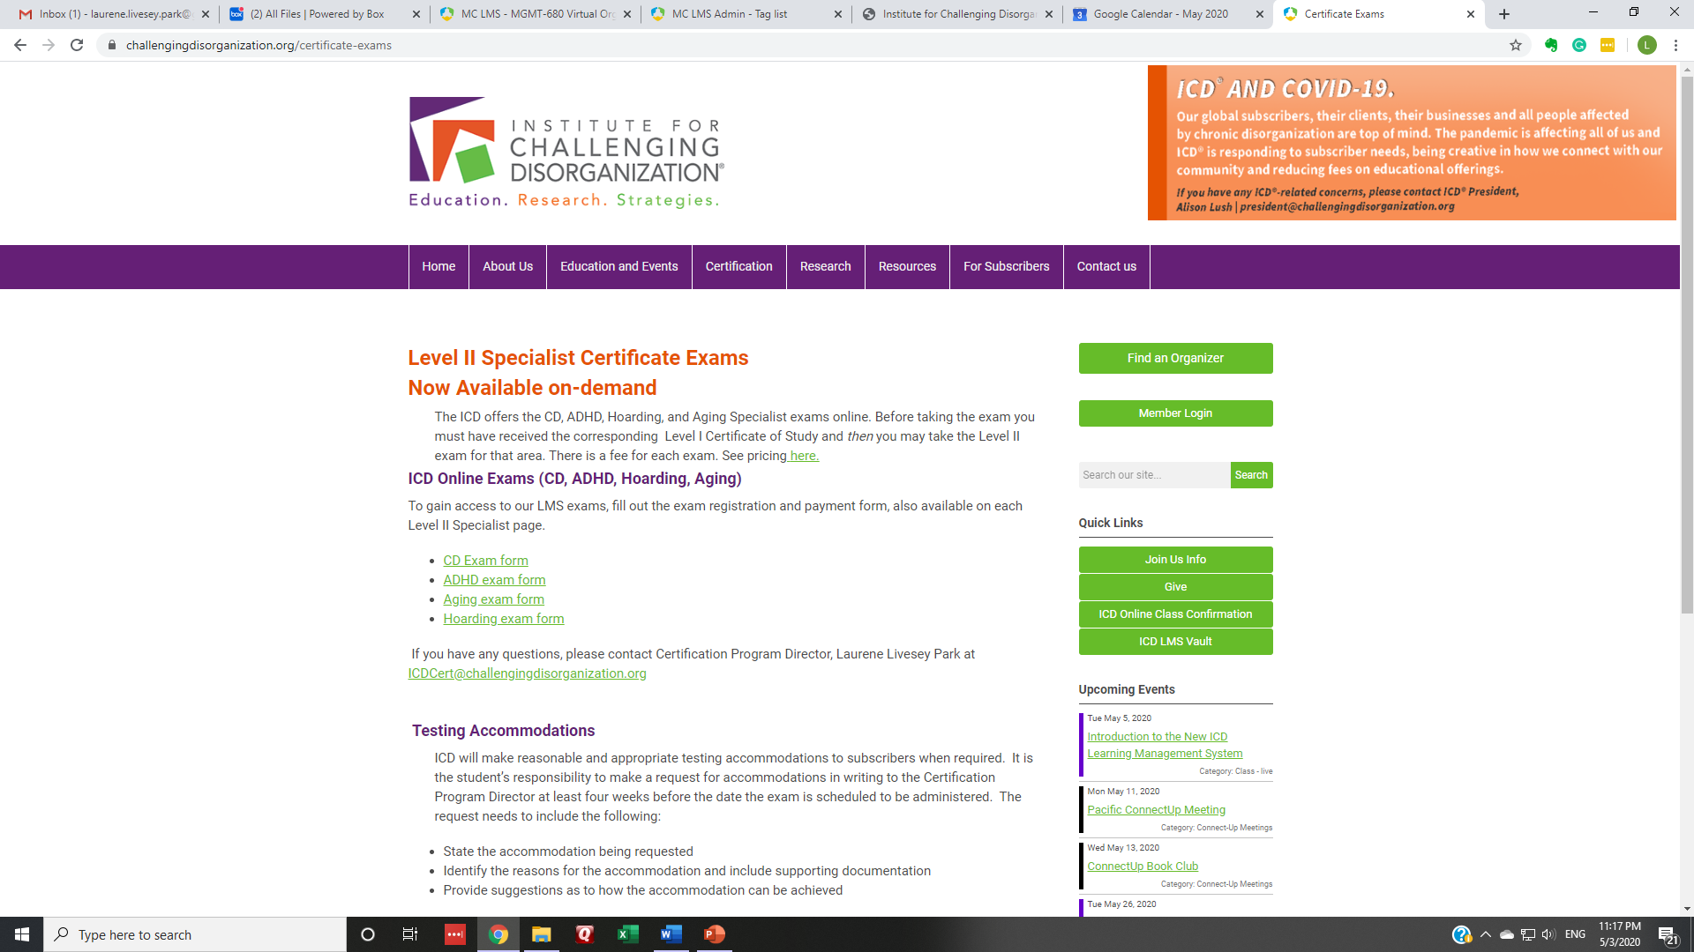

What exam do you want to access?
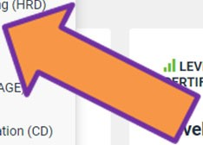

What exam do you want to access?
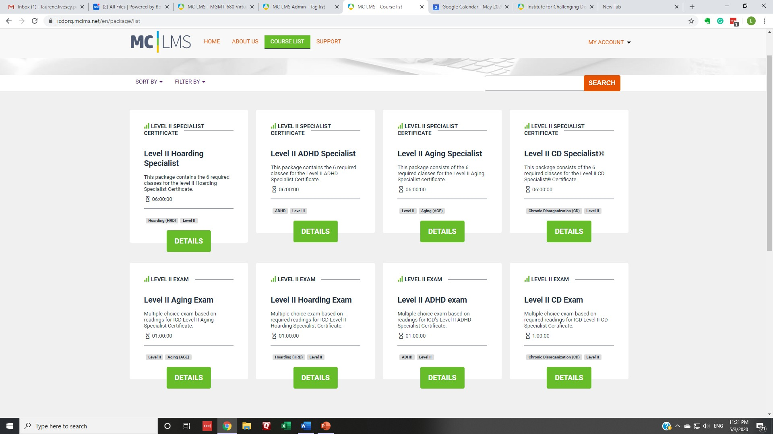

Two parts to exam access.
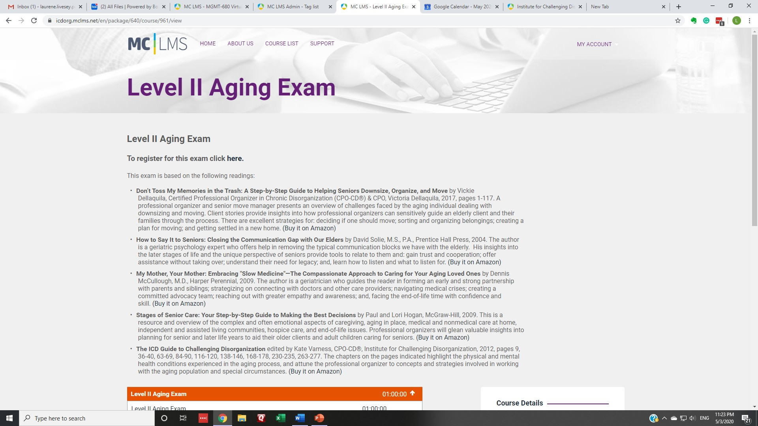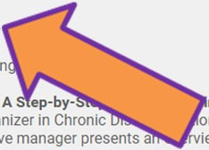1. Register and pay

Exam access
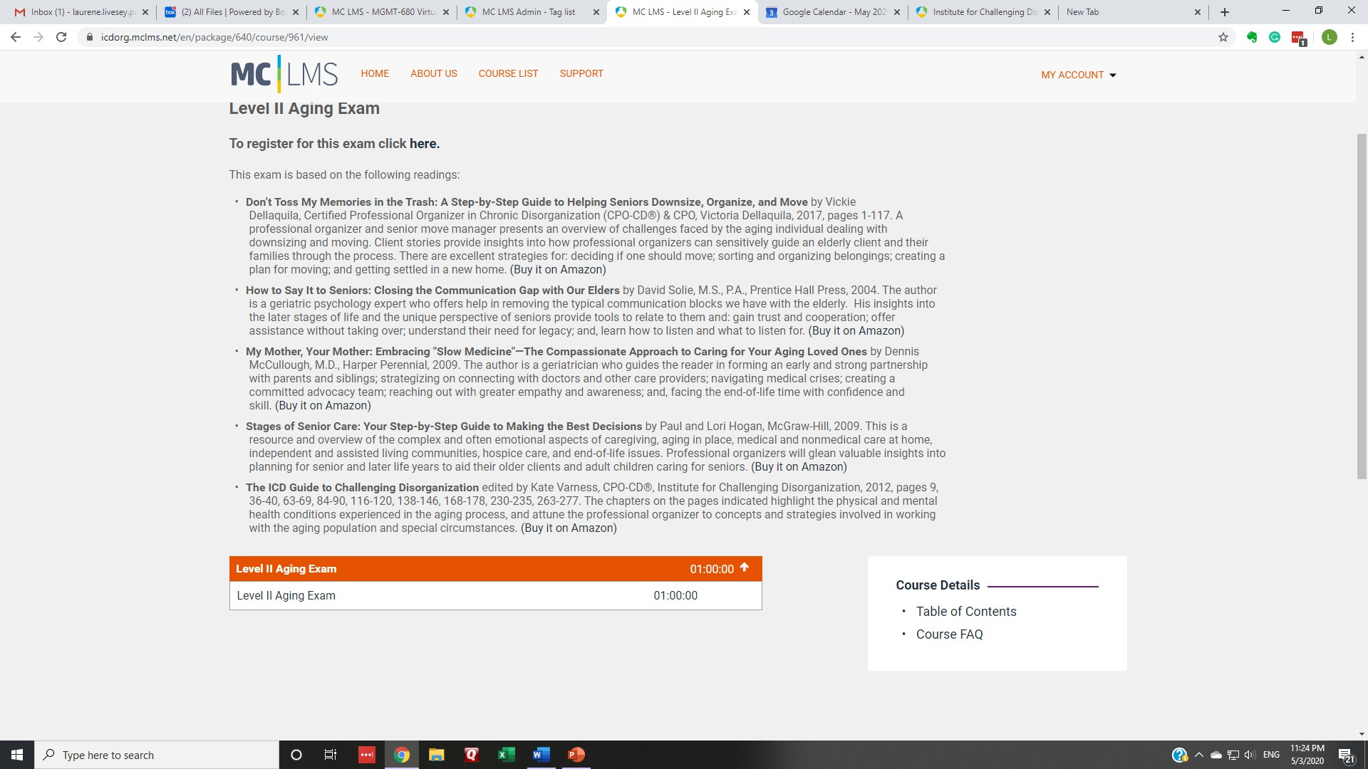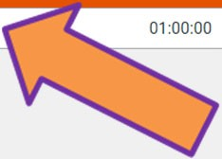

Level II Specialist Certificates

www.challengingdisorganization.org The ICD® Learning Management System
©2020 Institute for Challenging Disorganization
.All rights reserved.

Contact us at ICD@Challengingdisorganization.org

